**Are you interested in contributing to cancer research as a consumer representative?**

**Please get in touch if you would like to know more or join us for an information session and morning tea at ANU, *November 20, 2024***

We are a team of cancer researchers at ANU, led by Associate Professor Marian Burr, working on developing new, more effective treatments for various types of cancer, including lung cancer, melanoma and lymphoma. We are looking for people who have been impacted by cancer to form a consumer representative committee to provide input into the planning and sharing of our research. Please get in touch if you would like to find out more about what we do and how you could be involved.

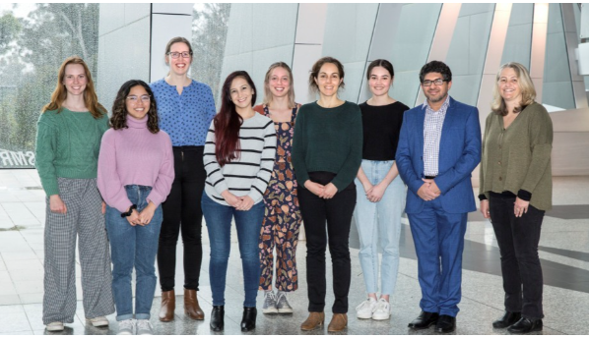

**We would love to meet you and hear your experiences if**

* You have or had any type of cancer, or
* You care for anyone who has or have had cancer in past and
* You are interested in cancer research and improving cancer treatment and would like to contribute by sharing your experience and providing input on the work we do.

**What can you expect?**

We are hosting an informal information session over morning tea, from 10 am – 12 pm on Wednesday 20th November at The John Curtin School of Medical Research, Building 131 Garran Road, Acton. You can also meet the team, visit our laboratories, see how we work, ask us any questions about our research and share your valuable thoughts and experience. If you would like to attend, **please RSVP** using <https://form.jotform.com/242621706027854> or email us at [burrlab.jcsmr@anu.edu.au.](mailto:burrlab.jcsmr@anu.edu.au)

If you would like to know more but cannot make it to this event, please let us know by completing the form <https://form.jotform.com/242657718514867> or email us at [burrlab.jcsmr@anu.edu.au](mailto:burrlab.jcsmr@anu.edu.au).